Jenkins-White Elementary School

***Parent and Family Engagement Policy and Plan for Shared Student Success***

*2023-2024 School Year*

*Jenkins-White Elementary School Dr. Sharro Usry-Wilson, Principal*

*Ms. Jessica Harris, Assist. Principal*

*800 15TH Street Avenue*

*706-737-7266*

*http://jenkinswhite,rcboe.org/home.aspx*

***Revised: June 7, 2023***

# What is Title I?

**Jenkins-White Elementary** is identified as a Title I school as part of Every Student Succeeds Act (ESSA). Title I is designed to support State and local school reform efforts tied to the challenging State academic standards to improve teaching and learning for students. Title I programs must be based on effective means of improving student achievement and include strategies to support family

engagement. All Title I schools must jointly

develop with parents and family

members a written parent and family engagement

policy.

# School Plan for Shared Student Achievement

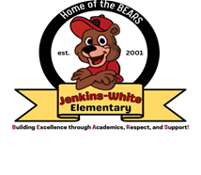

## What is it?

This is a plan that describes how **Jenkins-White Elementary** will provide opportunities to improve family engagement to support student learning.

**Jenkins-White Elementary** values the contributions and involvement of parents and family members to establish an equal partnership for the common goal of improving student achievement. This plan describes the different ways that

**Jenkins-White Elementary** will support family engagement and how parents can help plan and participate in activities and events to promote student learning at school and at home.

## How is it revised?

**Jenkins-White Elementary School** invited all parents to attend our annual School Forum last spring to review and revise this parent and family engagement policy, as well as the school wide plan, our school-parent compact, and the family engagement budget. Additionally, parent input and comments regarding this plan are welcome during the school year through an online form. The plan is posted on our school website for parents to view and submit feedback throughout the year. All parent feedback received during the year will be used to revise the plan for the next school year. We also distribute an annual survey online and by mail to ask parents for their suggestions on the plan and the use of funds for family engagement. Parents and family members can also give feedback during several parent meetings and activities during the school year.

## Who is it for?

All students participating in the Title I, Part A program, and their families are encouraged and invited to fully participate in the opportunities described in this plan. **Jenkins-White Elementary** will provide full opportunity for the participation of parents and family members with limited English, with disabilities, and of migratory children.

## Where is it available?

At the beginning of the year, the plan is included in the student handbook that is given to all students. The plan will also be posted on the school website and social media. Parents can also retrieve a copy of the plan in the Parent Resource Center and front office.

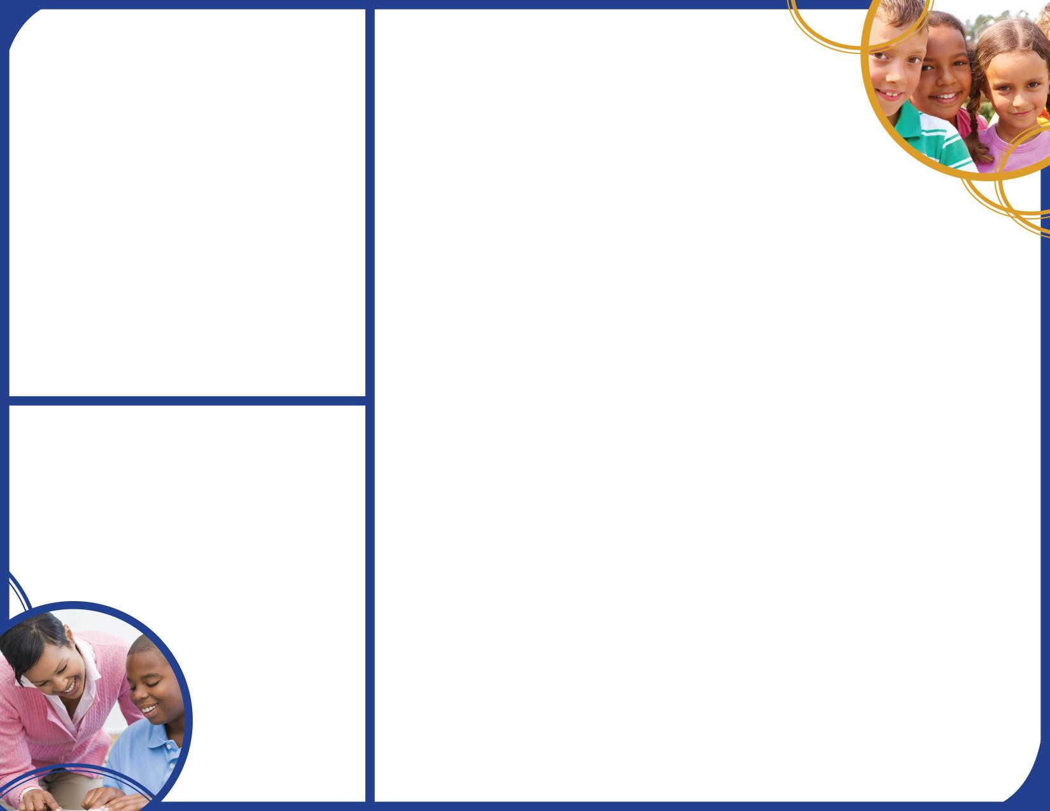

# Let’s Get Together!

RCSS will utilize technology and the RCSS Instructional

Framework to increase academic achievement across all tested content by 3 percent.

Through our Induction Support Program, RCSS will increase

the percentage of highly effective teachers and leaders retained in the RCSS by 3 percent.

RCSS will increase the graduation rate from 73.77% to 75% by a continued focus on the strategy map and working to produce graduates that meet the RCSS's Profile of a graduate.

2023-2024 District Goals

Jenkins White Elementary will host the following events to build the capacity for strong family engagement to support a partnership among the school, parents, and the community to improve student academic achievement.

2023-2024 JWES Goals

JWES will increase through differentiated professional learning, teachers will have multiple opportunities to improve their instructional systems by May 2024, as measured by 5% increases in TKES performance standards at Level III: Instructional Planning (58% to 63%) and Instructional Strategies (75% to 80%).

At least 5% (from 317 to 301) of our students will respond to our tiered intervention supports for behavior and SEL as evidenced by our office referrals and spotlight data analysis during the 2023-2024 school year 75% to 80%.

By May 2024, the percentage of students that score within the grade level stretch band on Georgia Milestones Assessment will increase by 3 percent. To include 3rd grade 12.4 to 15.4, 4th grade 14.4 to 17.4 and 5th grade 21.25 to 24.25

# School-Parent Compacts

As part of this plan, JW Elementary and our families will develop a school-parent compact, which is an *agreement* that parents, teachers, and students will develop that explains how parents and teachers will work together to make sure all our students reach grade-level standards. The compact will be reviewed and updated annually based on feedback from parents, students, and teachers on a survey. The

School-parent compact is are shared with parents during

parent-teacher conferences and

kept with each child’s teacher if parents

need another copy.

#### Open House: August 1, 2023

Meet your child’s teacher and our friendly and helpful school staff for the year.

***Grandparents Luncheon: September 8, 2023***

Meet your child’s teacher and our friendly and helpful school staff for the year.

***Annual Title I Meeting: September 14. 2023***

We invite you to an evening of learning and sharing about our Title I program, including our parent and family engagement policy, the school-wide plan, the school-parent compact, and parents’ requirements. A flyer will be sent home and a shout-point will be sent as a reminder. It will also be posted on the JWE school marquee.

***Fall Parent Conference Window: September 18-October 6, 2023***

Scheduled updates on your child’s progress.

#### Trunk and Trick Math Night: October 26, 2023

Learn how to make math fun at home.

#### Dads on Duty: November 5, 2023

#### Thanksgiving Dinner: TBA in November

#### Holiday Program: TBA in December

#### Science Fair Night

Gain knowledge about STEM and Science Fair projects.

***Valentine Hollywood Dance: February 16, 2024***

***Black History Program: February 2024***

Learn about history!

***Books and Burgers: February 29, 2024***

A celebration of Dr Seuss’ birthday

***Spring Parent Conference Window: February 20-March 8, 2024***

Scheduled updates on your child’s progress.

***Input and Revision Meeting: March 21, 2024***

A forum for parents and family members to participate in roundtable discussions with the principal and staff regarding the schoolwide plan, parent and family engagement policy, school-parent compact, and the family engagement budget.

#### Spring Carnival: TBA Spring 2024

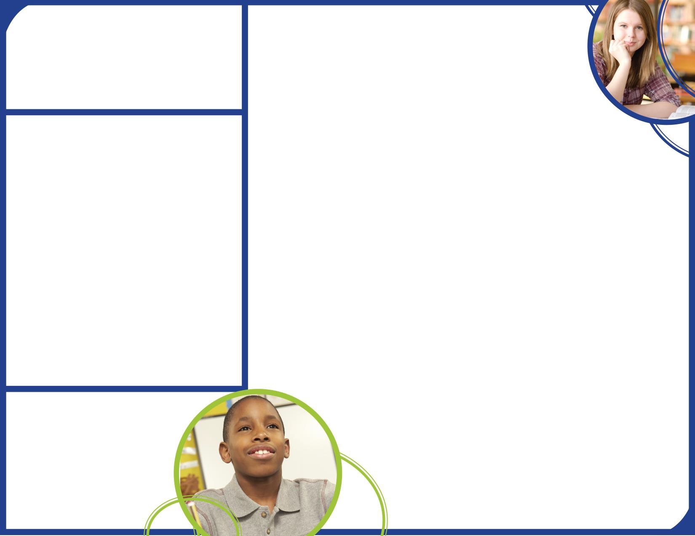**Parent Resource Center**

Come visit the Parent Resource Center to check out books, study materials, and activities to use at home with your child. Computers are available for parents to explore the Parent Portal and educational resources.

Monday – Friday, 9:00 am – 3:00 pm

**Parent and Family Engagement**

Jenkins-White Elementary believes that family engagement means the participation of parents and family members in regular two-way, meaningful communication involving student academic learning

and other school activities, including ensuring:

* That parents play an integral role in assisting their child’s learning.
* That parents are encouraged to be actively involved in their child’s education at school.
* That parents are full partners in their child’s education and are included, as appropriate, in

decision-making and on advisory committees to assist in the education of their child.

Jenkins-White Elementary is committed to helping our parents and families attend the family activities listed in this policy.

[Dr. Sharro Usry-Wilson (Principa](mailto:kingst1@boe.richmond.k12.ga.us)l) [usryni@boe.richmond.k12.ga.us](mailto:usryni@boe.richmond.k12.ga.us) [Mrs. Bullock (Parent Facilitat](mailto:Burnscr@richmond.k12.ga.us)or) [taylom](mailto:tayloma@boe.richmond.k12.ga.us)[a@boe.richmond.k12.ga.us](mailto:a@boe.richmond.k12.ga.us)

# Jenkins White Elementary is Branching Out!

**Jenkins-White Elementary** will take the following measures to promote and support parents and family members as an important foundation of the school in order to strengthen the school and reach our school goals. We will:

* + Ensure that all information related to school and parent programs, meetings, and other activities is posted on the school website, school marquee, phone shout points, and included in the monthly parent facilitator newsletter for all families.
  + Provide monthly trainings for staff during their planning periods on strategies to improve communication with parents and ideas to increase family engagement with reading and math activities for our students outside of the classroom. Staff will also share best practices during regularly scheduled faculty meetings.
  + Share information on the school blog and in the school web page for parents to understand the school’s academic standards and assessments as well as the ways parents can monitor their child’s progress and work with educators.
  + Communicate with all families and the community on a regular basis regarding schoolwide events and activities, through phone messages, school marquee, and flyers.
  + Work with our parents to develop relevant trainings and helpful presentations to educate our staff on the importance of parent and family engagement and how to support student learning.
  + Provide necessary materials and handouts for parents at conferences, meetings, and activities to help parents work with their child to improve their child’s achievement.
    - Collect feedback from parents and family members at all events, place input card around the building and a post suggestion form on the school website in order to respond to parents’ requests for additional support for parent and family engagement activities.

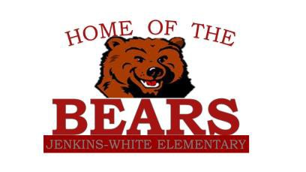

# Parent and Family Engagement Standards

If you would like to learn more about the School Council Team, please contact the

principal at 706-737-7266 or complete the interest form and leave it in the Main Office.

**Jenkins-White Elementary** and our parents have adopted the National PTA Standards for Family-School Partnerships as the school’s model in engaging parents, students, and the community. These standards are:

1. Welcoming All Families
2. Communicating Effectively
3. Supporting Student Success
4. Speaking Up for Every Child
5. Sharing Power
6. Collaborating with Community

# School Council Team

**Jenkins-White Elementary** invites all parents to join the School Council Team to share ideas and ways to involve other parents and family members to build partnerships with school, families, and the community. The team will meet four times during the school year, but parents and family members can also submit their ideas

or suggestions at any school activities and

meetings, as well

School Council



* Yes, I am interested and wish to join the School Community Team.
* Please contact me so I can learn more in joining the School Community Team.
* Please send me notifications about future meetings and updates.

Name: Child’s Name and Grade: Address: Phone Number:

# Share Your Thoughts

We want to hear from you. If you have any suggestions or if there is any part of this policy that you feel is not satisfactory with the students’ and the school’s goals for academic achievement, please provide us with your comments in the space provided and leave this form in the Main Office:

Name: (optional)

Telephone Number: (optional)

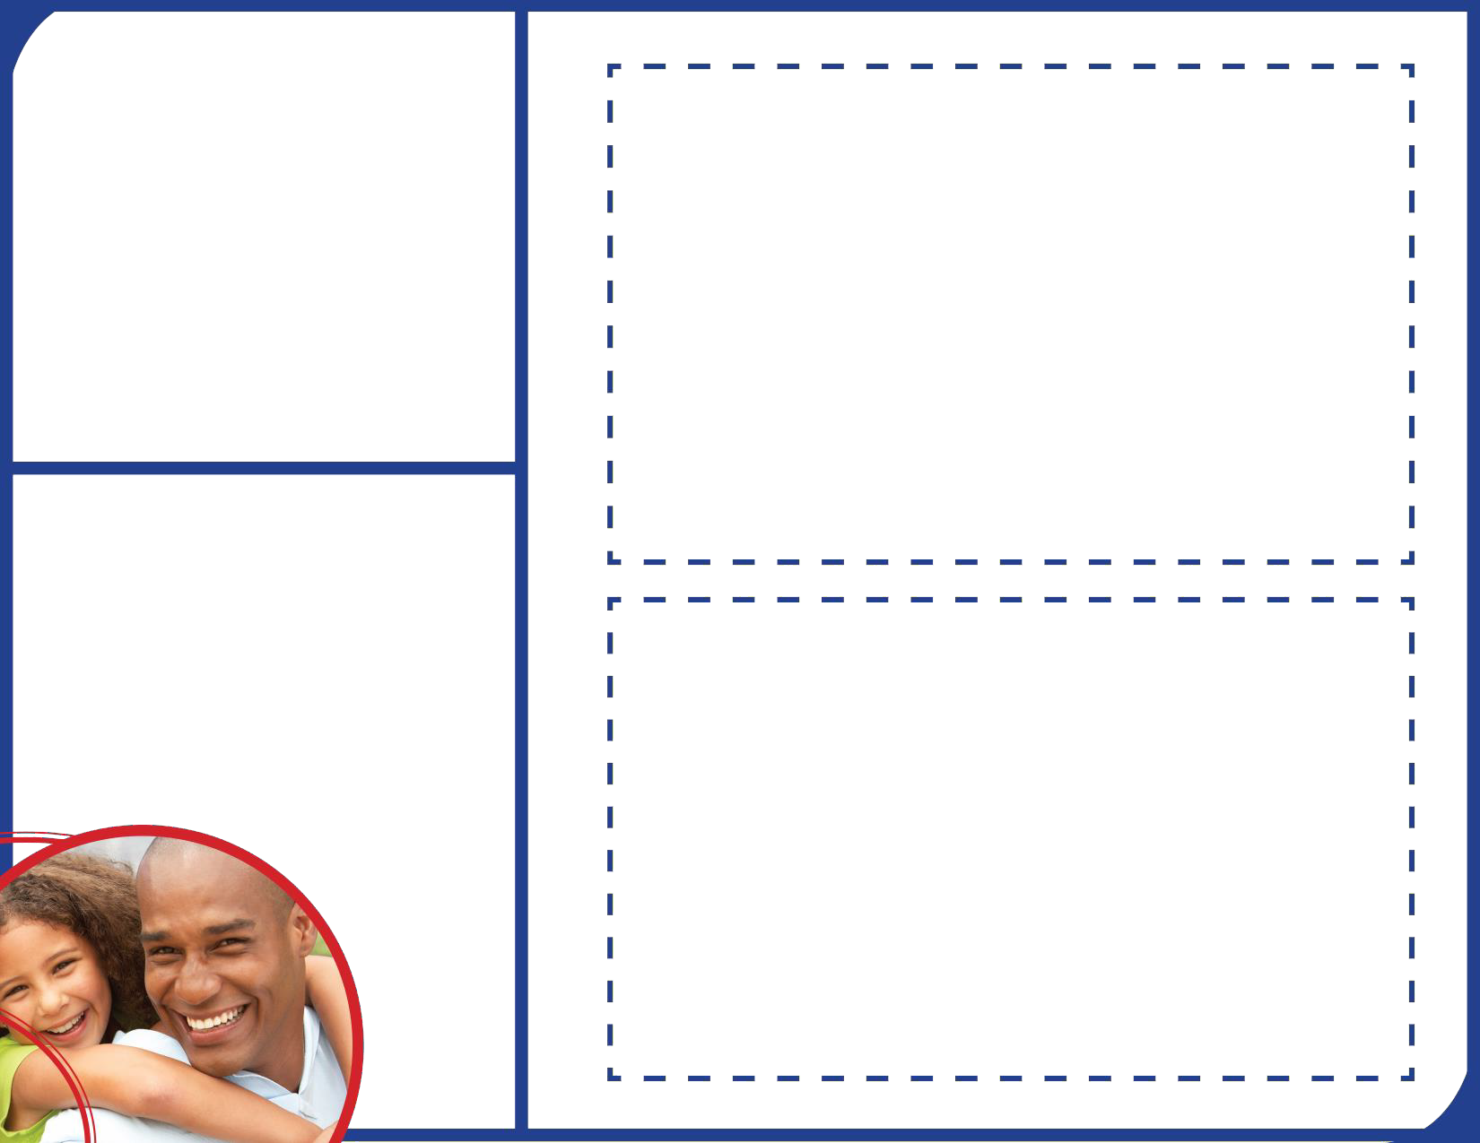 as through our

parent surveys and website.